**Project 2 - Part 1**

After reading this article, I didn't immediately search for what this building was like. According to the article, my mind was full of a Japanese building with low-saturated sandy walls, accompanied by beautiful light and shadows, and the whole picture looked very comfortable, as if it was an afternoon scene of drinking hot tea and immediately napping.

The article focuses on the relationship between shadows and light, and in particular uses a particular number of metaphors to describe these shadows.

In my designed interpretation, I want to show the feeling which shadow and light give to us. The description of the shadow in the article is really beautiful, although everyone reads it differently, but I want to restore this feeling as much as possible.

1. Neutral color

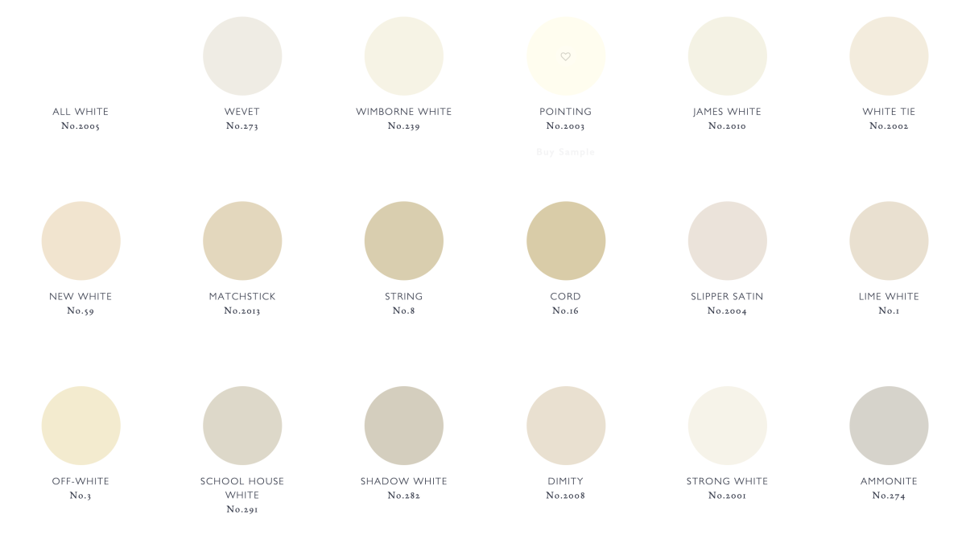

1. Absolute repose

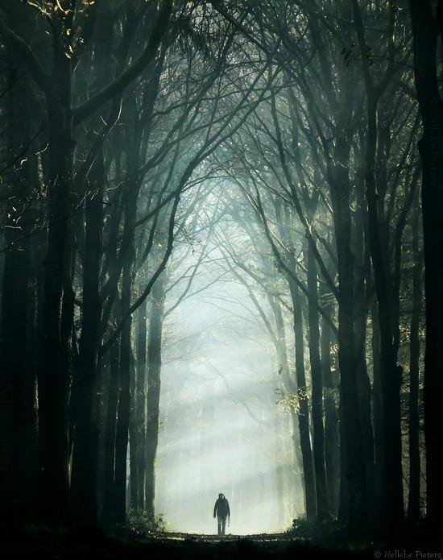

1. Pale glow
2. Dim shadows
3. Inexpressible chill
4. Cold and desolate tinge
5. Reflection
6. Gold leaf and gold dust



1. Temple
2. Ink wash painting

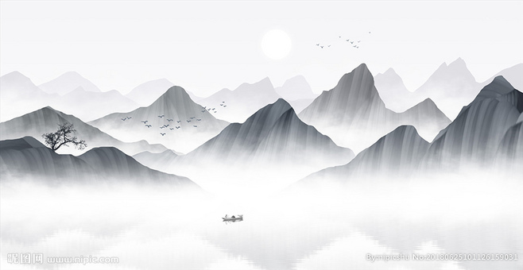

**In Praise of Shadows**

## An Excerpt by Jun'ichiro Tanizaki

I possess no specialized knowledge of architecture, but I understand that in the Gothic cathedral of the West, the roof is thrust up and up so as to place its pinnacle as high in the heavens as possible-and that herein is thought to lie its special beauty. In the temples of Japan, on the other hand, a roof of heavy tiles is first laid out, and in the deep, spacious shadows created by the eaves the rest of the structure is built. Nor is this true only of temples; in the palaces of the nobility and the houses of the common people, what first strikes the eye is the massive roof of tile or thatch and the heavy darkness that hangs beneath the eaves. Even at midday cavernous darkness spreads over all beneath the roof's edge, making entryway, doors, walls, and pillars all but invisible. The grand temples of Kyoto-Chion'in, Honganji-and the farmhouses of the remote countryside are alike in this respect: like most buildings of the past their roofs give the impression of possessing far greater weight, height, and surface than all that stands beneath the eaves.

**Paragraph 1 Features**

1. Roof - Gothic cathedral VS. Temples of Japan

In making for ourselves a place to live, we first spread a parasol to throw a shadow on the earth, and in the pale light of the shadow we put together a house. There are of course roofs on Western houses too, but they are less to keep off the sun than to keep off the wind and the dew; even from without it is apparent that they are built to create as few shadows as possible and to expose the interior to as much light as possible. If the roof of a Japanese house is a parasol, the roof of a Western house is no more than a cap, with as small a visor as possible so as to allow the sunlight to penetrate directly beneath the eaves. There are no doubt all sorts of reasons-climate, building materials-for the deep Japanese eaves. The fact that we did not use glass, concrete, and bricks, for instance, made a low roof necessary to keep off the driving wind and rain. A light room would no doubt have been more convenient for us, too, than a dark room. The quality that we call beauty, however, must always grow from the realities of life, and our ancestors, forced to live in dark rooms, presently came to discover beauty in shadows, ultimately to guide shadows towards beauty's ends.

**Paragraph 2 Features**

1. Light and shadow of roof - Western house VS. Japan house
2. Western roof is use to keep off the sun than to keep off the wind and the dew, opposite of Japanese roof
3. Light room VS. Dark room

And so it has come to be that the beauty of a Japanese room depends on a variation of shadows, heavy shadows against light shadows-it has nothing else. Westerners are amazed at the simplicity of Japanese rooms, perceiving in them no more than ashen walls bereft of ornament. Their reaction is understandable, but it betrays a failure to comprehend the mystery of shadows. Out beyond the sitting room, which the rays of the sun can at best but barely reach, we extend the eaves or build on a veranda, putting the sunlight at still greater a remove. The light from the garden steals in but dimly through paper-paneled doors, and it is precisely this indirect light that makes for us the charm of a room. We do our walls in neutral colors so that the sad, fragile, dying rays can sink into absolute repose. The storehouse, kitchen, hallways, and such may have a glossy finish, but the walls of the sitting room will almost always be of day textured with fine sand. A luster here would destroy the soft fragile beauty of the feeble light. We delight in the mere sight of the delicate glow of fading rays clinging to the surface of a dusky wall, there to live out what little life remains to them. We never tire of the sight, for to us this pale glow and these dim shadows far surpass any ornament. And so, as we must if we are not to disturb the glow, we finish the walls with sand in a single neutral color. The hue may differ from room to room, but the degree of difference will be ever so slight; not so much a difference in color as in shade, a difference that will seem to exist only in the mood of the viewer. And from these delicate differences in the hue of the walls, the shadows in each room take on a tinge peculiarly their own.

**Paragraph 3 Features**

1. Different level of shadow - Japanese room

Of course the Japanese room does have its picture alcove, and in it a hanging scroll and a flower arrangement. But the scroll and the flowers serve not as ornament but rather to give depth to the shadows. We value a scroll above all for the way it blends with the walls of the alcove, and thus we consider the mounting quite as important as the calligraphy or painting. Even the greatest masterpiece will lose its worth as a scroll if it fails to blend with the alcove, while a work of no particular distinction may blend beautifully with the room and set off to unexpected advantage both itself and its surroundings. Wherein lies the power of an otherwise ordinary work to produce such an effect? Most often the paper, the ink, the fabric of the mounting will possess a certain look of antiquity, and this look of antiquity will strike just the right balance with the darkness of the alcove and room.

**Paragraph 4 features**

1. Private alcove in Japanese room

We have all had the experience, on a visit to one of the great temples of Kyoto or Nara, of being shown a scroll, one of the temple's treasures, hanging in a large, deeply recessed alcove. So dark are these alcoves, even in bright daylight, that we can hardly discern the outlines of the work; all we can do is listen to the explanation of the guide, follow as best we can the all-but invisible brush strokes, and tell ourselves how magnificent a painting it must be. Yet the combination of that blurred old painting and the dark alcove is one of absolute harmony. The lack of clarity, far from disturbing us, seems rather to suit the painting perfectly.

**Paragraph 5 features**

1. Example of shadow, private alcove in temple of Japan

For the painting here is nothing more than another delicate surface upon which the faint, frail light can play; it performs precisely the same function as the sand-textured wall. This is why we attach such importance to age and patina. A new painting, even one done in ink monochrome or subtle pastels, can quite destroy the shadows of an alcove, unless it is selected with the greatest care.

A Japanese room might be likened to an inkwash painting, the paper-paneled shoji being the expanse where the ink is thinnest, and the alcove where it is darkest. Whenever I see the alcove of a tastefully built Japanese room, I marvel at our comprehension of the secrets of shadows, our sensitive use of shadow and light. For the beauty of the alcove is not the work of some clever device. An empty space is marked off with plain wood and plain walls, so that the light drawn into it forms dim shadows within emptiness. There is nothing more. And yet, when we gaze into the darkness that gathers behind the crossbeam, around the flower vase, beneath the shelves, though we know perfectly well it is mere shadow, we are overcome with the feeling that in this small corner of the atmosphere there reigns complete and utter silence; that here in the darkness immutable tranquility holds sway. *The "mysterious Orient" of which Westerners speak probably refers to the uncanny silence of these dark places.* And even we as children would feel an inexpressible chill as we peered into the depths of an alcove to which the sunlight had never penetrated. Where lies the key to this mystery? illtimately it is the magic of shadows. Were the shadows to be banished from its comers, the alcove would in that instant revert to mere void.

**Paragraph 6/7 Features**

1. Metaphor of shadow of Japanese house

This was the genius of our ancestors, that by cutting off the light from this empty space they imparted to the world of shadows that formed there a quality of mystery and depth superior to that of any wall painting or ornament. The technique seems simple, but was by no means so simply achieved. We can imagine with little difficulty what extraordinary pains were taken with each invisible detail-the placement of the window in the shelving recess, the depth of the crossbeam, the height of the threshold. But for me the most exquisite touch is-the pale white glow of the shoji in the study bay; I need only pause before it and I forget the passage of time.

The study bay, as the name suggests, was originally a projecting window built to provide a place for reading. Over the years it came to be regarded as no more than a source of light for the alcove; but most often it serves not so much to illuminate the alcove as to soften the sidelong rays from without, to filter them through paper panels. There is a cold and desolate tinge to the light by the time it reaches these panels. The little sunlight from the garden that manages to make its way beneath the eaves and through the corridors has by then lost its power to illuminate, seems drained of the complexion of life. It can do no more than accentuate the whiteness of the paper. I sometimes linger before these panels and study the surface of the paper, bright, but giving no impression of brilliance.

**Paragraph 9 Features**

1. Light example in study bay

In temple architecture the main room stands at a considerable distance from the garden; so dilute is the light there that no matter what the season, on fair days or cloudy, morning, midday, or evening, the pale, white glow scarcely varies. And the shadows at the interstices of the ribs seem strangely immobile, as if dust collected in the corners had become a part of the paper itself. I blink in uncertainty at this dreamlike luminescence, feeling as though some misty film were blunting my vision. The light from the pale white paper, powerless to dispel the heavy darkness of the alcove, is instead repelled by the darkness, creating a world of confusion where dark and light are indistinguishable. Have not you yourselves sensed a difference in the light that suffuses such a room, a rare tranquility not found in ordinary light? Have you never felt a sort of fear in the face of the ageless, a fear that in that room you might lose all consciousness of the passage of time, that untold years might pass and upon emerging you should find you had grown old and gray?

**Paragraph 10 Features**

1. Light feeling in main room

And surely you have seen, in the darkness of the innermost rooms of these huge buildings, to which sunlight never penetrates, how the gold leaf of a sliding door or screen will pick up a distant glimmer from the garden, then suddenly send forth an ethereal glow, a faint golden light cast into the enveloping darkness, like the glow upon the horizon at sunset. In no other setting is gold quite so exquisitely beautiful. You walk past, turning to look again, and yet again; and as you move away the golden surface of the paper glows ever more deeply, changing not in a flash, but growing slowly, steadily brighter, like color rising in the face of a giant. Or again you may find that the gold dust of the background, which until that moment had only a dull, sleepy luster, will, as you move past, suddenly gleam forth as if it had burst into flame.

How, in such a dark place, gold draws so much light to itself is a mystery to me. But I see why in ancient times statues of the Buddha were gilt with gold and why gold leaf covered the walls of the homes of the nobility. Modem man, in his well-lit house, knows nothing of the beauty of gold; but those who lived in the dark houses of the past were not merely captivated by its beauty, they also knew its practical value; for gold, in these dim rooms, must have served the function of a reflector. Their use of gold leaf and gold dust was not mere extravagance. Its reflective properties were put to use as a source of illumination. Silver and other metals quickly lose their gloss, but gold retains its brilliance indefinitely to light the darkness of the room. This is why gold was held in such incredibly high esteem.